# PROSIT STATISTICS AND CONTINUOUS LAWS s

### Animateur : Mohamed

### Scribe : Elio

### Gestionnaire : Idris

### Secrétaire : Tisha

## KEYWORDS: A

* Computer operating systems - software that manages and handles the hardware and software resources of a computer system. It provides interaction between users of computers and computer hardware. It is also responsible for managing and controlling all the activities and sharing of computer resources.
* CPU - Central Processing Unit is the hardware that performs data input/output, processing, and storage functions for a computer system.
* Descriptive / Data statistic - Descriptive statistics describes the collected data without drawing conclusion about the population. Data refers to raw information collected from observations, experiments, surveys, or measurements. It can be quantitative (numerical) or qualitative (categorical) and serves as the foundation for analysis and decision-making.
* Monitoring tools - A monitoring tool is a software application used in computer systems to track various metrics such as CPU load, network bandwidth, server services, and disk space to detect issues and alert administrators before users are affected.
* Network traffic - Network traffic is the amount of data moving across a computer network at any given time. Network traffic, also called data traffic, is broken down into data packets and sent over a network before being reassembled by the receiving device or computer.
* Real-time data - Real time data is information that is updated continuously and available immediately or almost immediately. Real-time data is available for access as it is generated or collected or after real time analysis without significant delay.
* Network performance - Network performance refers to the quality and effectiveness of a network system. It involves evaluating and reviewing the speed, connectivity, reliability, and efficiency of a network.
* Memory management - The task of subdividing the memory among different processes is called Memory Management. It is a method in the operating system to manage operations between main memory and disk during process execution. The main aim of memory management is to achieve efficient utilization of memory.
* Data-driven alertness thresholds - Data-driven alerts allow interactors to set threshold on the numeric axis of the view and receive emails only when the data exceeds the defined threshold, it also allows interactors to define how often to receive the emails.
* Predictive methods - Predictive analytics is the use of statistics and modeling techniques to forecast future outcomes.
* Optimize system performance - the process of modifying a system to amplify its functionality, thus making it more efficient and effective.

**CONTEXT: X**

OPTIMAL seeks to improve the management of its IT systems by optimizing memory usage and monitoring server performance.

## CONSTRAINTS: A

* Python
* CSV
* Datasets
* Time taken ( frequency )

## PROBLEM STATEMENT: A

* How can the performance of CPU, memory, and network systems at OPTIMAL be effectively analyzed and optimized to improve overall system efficiency and reduce operational costs ?

## DELIVERABLES: A

* Identify performance bottlenecks in CPU, memory, and network usage.
* Predictive method to proactively optimize system performance.

## SOLUTION APPROACHES: A

* Analyze the given graphs, time series ( frequency )
* Find max performance

## ACTION PLAN: A

1. Study OS, CPU, Memory management
2. Study continuous laws of statistics
3. Time trend analysis
4. Analyze collected data
5. Process data
6. Identify Problem
7. Find solution to optimize IT systems

**SOLUTION: d**

**OPERATING SYSTEM**

It is the interface between the user and the computer hardware.

Types of OS:

* Batch OS – A set of similar jobs are stored in the main memory for execution. A job gets assigned to the CPU, only when the execution of the previous job completes.
* Multiprogramming OS – The main memory consists of jobs waiting for CPU time. The OS selects one of the processes and assigns it to the CPU. Whenever the executing process needs to wait for any other operation (like I/O), the OS selects another process from the job queue and assigns it to the CPU. This way, the CPU is never kept idle and the user gets the flavor of getting multiple tasks done at once.
* Multitasking OS – Multitasking OS combines the benefits of Multiprogramming OS and CPU scheduling to perform quick switches between jobs. The switch is so quick that the user can interact with each program as it runs
* Time Sharing OS – Time-sharing systems require interaction with the user to instruct the OS to perform various tasks. The OS responds with an output. The instructions are usually given through an input device like the keyboard.
* Real Time OS – Real-Time OS are usually built for dedicated systems to accomplish a specific set of tasks within deadlines.

Threads: A thread is a lightweight process and forms the basic unit of CPU utilization. A process can perform more than one task at the same time by including multiple threads.

* A thread has its own program counter, register set, and stack
* A thread shares resources with other threads of the same process the code section, the data section, files and signals.

Process: A process is a program under execution. The value of program counter (PC) indicates the address of the next instruction of the process being executed. Each process is represented by a Process Control Block (PCB).

Process Scheduling:

* Arrival Time – Time at which the process arrives in the ready queue.
* Completion Time – Time at which process completes its execution.
* Burst Time – Time required by a process for CPU execution.
* Turn Around Time – Time Difference between completion time and arrival time.
* Waiting Time (WT) – Time Difference between turn around time and burst time.

Objectives of Process Scheduling Algorithm:

* Max CPU utilization (Keep CPU as busy as possible)
* Fair allocation of CPU.
* Max throughput (Number of processes that complete their execution per time unit)
* Min turnaround time (Time taken by a process to finish execution)
* Min waiting time (Time for which a process waits in ready queue)
* Min response time (Time when a process produces first response)

Memory Management Techniques:

* Single Partition Allocation Schemes – The memory is divided into two parts. One part is kept to be used by the OS and the other is kept to be used by the users.
* Multiple Partition Schemes –
  + Fixed Partition – The memory is divided into fixed size partitions.
  + Variable Partition – The memory is divided into variable sized partitions.
* Variable partition allocation schemes:
  + First Fit – The arriving process is allotted the first hole of memory in which it fits completely.
  + Best Fit – The arriving process is allotted the hole of memory in which it fits the best by leaving the minimum memory empty.
  + Worst Fit – The arriving process is allotted the hole of memory in which it leaves the maximum gap.

Paging – The physical memory is divided into equal sized frames. The main memory is divided into fixed size pages. The size of a physical memory frame is equal to the size of a virtual memory frame.

Segmentation – Segmentation is implemented to give users view of memory. The logical address space is a collection of segments. Segmentation can be implemented with or without the use of paging.

**CENTRAL PROCESSING UNIT**

CPU [Central Processing Unit] is the brain of the computer. All types of data processing operations from simple arithmetic to complex tasks and all the important functions of a computer are performed by the CPU. It helps input and output devices to communicate with each other and perform their respective operations. It also stores data which is input, intermediate results in between processing, and instructions. The CPU’s job is to make sure everything runs smoothly and efficiently.

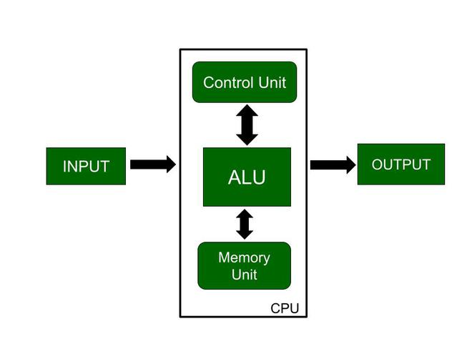

Memory or Storage Unit

* Responsible for transferring information to other units of the computer when needed.
* Also known as an internal storage unit or the main memory or the primary storage or Random Access Memory (RAM) as all these are storage devices.
* There are two types of memory in the computer, which are primary memory and secondary memory.
* Main functions of memory units are listed below:
  + Data and instructions are stored in memory units which are required for processing.
  + It also stores the intermediate results of any calculation or task when they are in process.
  + The final results of processing are stored in the memory units before these results are released to an output device for giving the output to the user.
  + All sorts of inputs and outputs are transmitted through the memory unit.

Control Unit

* Controlling of data and transfer of data and instructions is done by the control unit among other parts of the computer.
* The control unit is responsible for managing all the units of the computer.
* The main task of the control unit is to obtain the instructions or data that is input from the memory unit, interpret them, and then direct the operation of the computer according to that.
* The control unit is responsible for communication with Input and output devices for the transfer of data or results from memory.
* The control unit is not responsible for the processing of data or storing data.

Arithmetic Logic Unit (ALU)

* Arithmetic Section: operations like addition, subtraction, multiplication, and division, and all these operations and functions are performed by ALU. Also, all the complex operations are done by making repetitive use of the mentioned operations by ALU.
* Logic Section: operations or functions like selecting, comparing, matching, and merging the data, and all these are performed by ALU.

The main function of a computer processor is to execute instructions and produce an output:

* Fetch: the first CPU gets the instruction. That means binary numbers that are passed from RAM to CPU.
* Decode: When the instruction is entered into the CPU, it needs to decode the instructions. with the help of ALU(Arithmetic Logic Unit), the process of decoding begins.
* Execute: After the decode step the instructions are ready to execute.
* Store: After the execute step the instructions are ready to store in the memory.

CPU Performance

CPU performance is how fast a computer’s processor (CPU) can complete the task. It is measured by the number of instructions completed in one second. Its performance depends on the processor’s clock speed and other factors like its design and the size of its cache.

Advantages

* Versatility: CPU can able to handle a complex task, from basic calculation to managing the operating system.
* Performance: Modern CPU are vary fast and able to perform billions of calculation per second.
* Multi-core: CPU have multiple core and able to handle multiple task simultaneously.
* Compatibility: CPUs are designed to be compatible with a wide range of software, this help to run different applications by using single CPU.

Disadvantages

* Overheating: CPU generate a lot of heat while performing complex task. This requires effective cooling solutions, such as fans or liquid cooling systems.
* Power Consumption: High-performance CPUs can consume a vary high amount of power, which cause to generate higher electricity bills and the need for a robust power supply.
* Cost: Best performance CPU can be expensive. Which can be a barrier for some users or applications that need high computing power.
* Limited Parallel Processing: While multi-core CPUs can handle multiple tasks at once, they are still not as efficient at parallel processing as specialized hardware like GPUs (Graphics Processing Units), which are designed for handling many tasks simultaneously.

**MEMORY MANAGEMENT**

Main Memory

* The main memory is central to the operation of a Modern Computer.
* It is a large array of words or bytes, ranging in size from hundreds of thousands to billions.
* It is a repository of rapidly available information shared by the CPU and I/O devices.
* It is the place where programs and information are kept when the processor is effectively utilizing them.
* It is associated with the processor, so moving instructions and information into and out of the processor is extremely fast.
* Also known as RAM (Random Access Memory). This memory is volatile. RAM loses its data when a power interruption occurs.

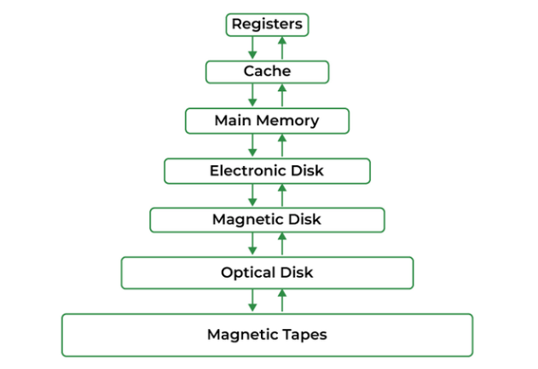

Memory Management Definition

* In a multiprogramming computer, the Operating System resides in a part of memory, and the rest is used by multiple processes.
* The task of subdividing the memory among different processes is called Memory Management.
* Memory management is a method in the operating system to manage operations between main memory and disk during process execution.
* The main aim of memory management is to achieve efficient utilization of memory.

Requirement of Memory Management

* Allocate and de-allocate memory before and after process execution.
* To keep track of used memory space by processes.
* To minimize fragmentation issues.
* To proper utilization of main memory.
* To maintain data integrity while executing of process.

Memory Leak

* A memory leak occurs when a program fails to release memory that it no longer needs, resulting in wasted memory resources.
* Over time, if memory leaks accumulate, the system’s available memory diminishes, leading to reduced performance and possibly system crashes.

**CONTINUOUS LAWS OF STATISTICS**

Continuous Probability Distribution

A probability distribution in which the random variable X can take on any value (is continuous). Because there are infinite values that X could assume, the probability of X taking on any one specific value is zero.

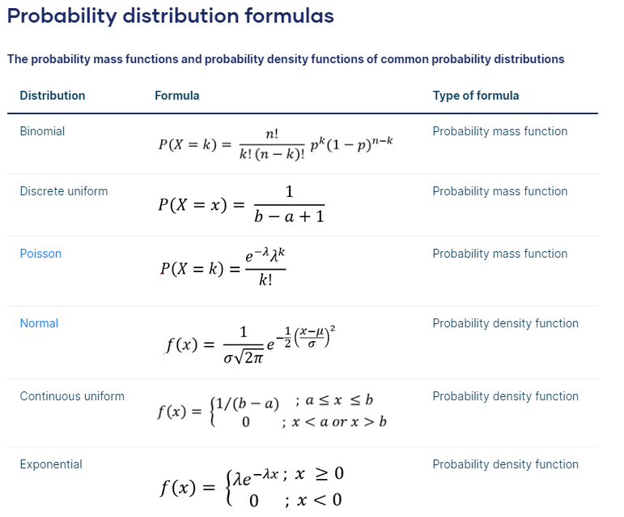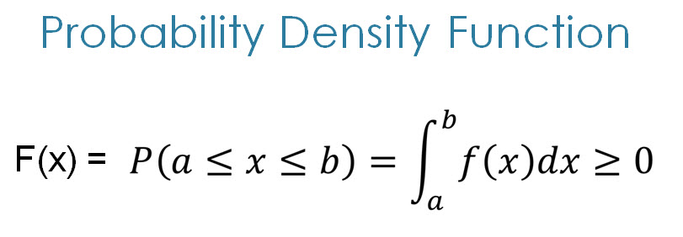

Probability Mass Function

* Use PMF only for discrete random variables.

Probability Density Function

* We say PDF or simply a density function for a general random variable

Cumulative distribution function (CDF)

* 